**RGA Process- Repair**

* The vendors who will ask this of us:
  + Most of the time, Windward
  + Sometimes, Capris
  + Sometimes, Tropitone
  + Rarely, Sunbrella and Pride

For Windward, Tropitone and Capris

* This process begins when a filed claim has been honored.
* When the vendor responds to your claim, they will tell you that they want the product back for repair. If they do not provide you with a PDF copy of RGA paperwork that includes an RGA number, you will need to request this from them.
  + If it is Windward honoring the claim, they will first ask you for a PO to return the product for repair. What they want is a copy of the PO that we created to receive our CUSM into the warehouse on. Windward wants this information for tracking purposes in their system. Other vendors will not ask for this.
  + The RGA paperwork with the RGA number is what we will use to label the product that is being sent back to the vendor. It allow both our teams and theirs to identify what it is and why it’s being transported.
* Below are RGA for Repair paperwork examples:

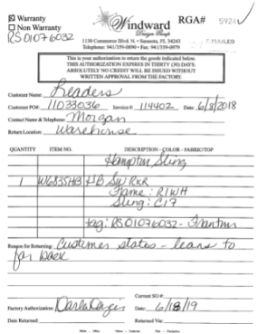 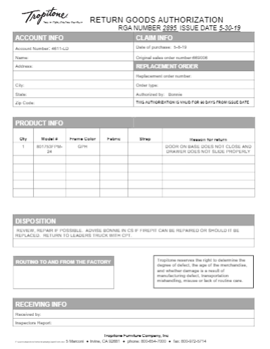

* If for some reason the vendor is unable or unwilling to provide a hard copy of RGA paperwork, we will create our own for tracking purposes. You will do this by using the “Master RS Form (Blank)” document located in **R:\10 About the Solutions Center (Service)\6.0 Forms**. (Additional details on how to fill out if needed for Capris or other Vendor that does not provide paperwork)
* Once the paperwork is received, a Wrike request will need to be created for tracking purposes. This request can be filled out as soon as the RGA paperwork is received. The customer’s CUSM does not have to be here for this request to be entered. Solutions is the only group who will update the status on these particular requests.
* To enter in the Wrike request, go to your Wrike work space and select the green plus sign toward the top right of your screen, the same spot you go to in order to enter the Repair and Cushion Shop Requests, except the form you select will be the RGA Request.

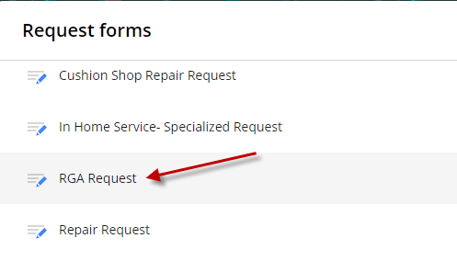

* Follow the prompts to enter all of the necessary information the same as you would for a Cushion Shop or Repair Request. Make sure that a copy of the RGA is attached to the request form when prompted. The next step will not be taken until the CUSM product has been received to the warehouse.
* When the CUSM arrives, we can now schedule it to be sent over to the vendor. In order to do that you will need to go into your “Shipping/Billing/Signature” tab in the CUSM sales order and change the address to the vendor the product will be going to.
  + To find vendor’s address, simply do a Global NetSuite Search for the vendor you need by typing “Ven: _____” and then the name of the company. This will bring you to a clickable link that will migrate you to the Vendor Information page.
  + To find the address you need, look in the Address tab and only use the address if it is located in Florida. The product will be being scheduled onto one of our regular delivery trucks.
  + During the scheduling process please add the note “DO NOT CALL CUSTOMER, PRODUCT BEING SENT BACK TO VENDOR FOR REPAIR” to the Delivery Memo section. This will ensure that the customer is not called with a timeframe in error.
* Once the address has been changed, schedule the sales order following standard scheduling practices. Take note of the day you schedule it for. This will be important for the next step.
* Go back into your Wrike request, you will find it listed in the “On Dock” section. Change the status code to “Waiting for Confirmation” and the due date to the day you scheduled the delivery for. Update the case notes accordingly.

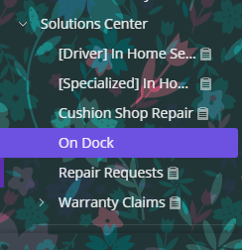

* Print out the RGA paperwork that you loaded into the Wrike request when you first entered it. You will need to print out one copy of the paperwork for each individual item that is being sent to the vendor.
* The afternoon before delivery, pull up the delivery record and look to see what door the product has been loaded into. Take your paperwork downstairs and staple a copy of the paperwork to each of the pieces being sent back.

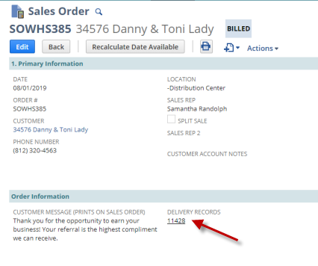

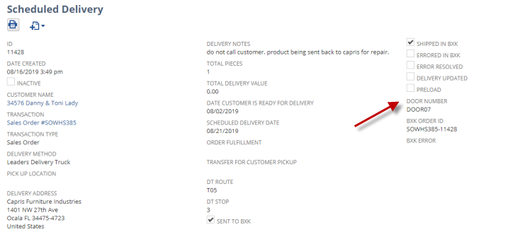

* Email the vendor to let them know that the product is coming back. (Windward RGA Group email so that Peter and Jenny can be included?)
* Update the status of the case to reflect that the product is back at the vendor.
* Update the Wrike request to “Unconfirmed Completion” and set the due date for three weeks out.
* At any point after the product has been delivered to the vendor, we will need to update NetSuite to reflect that the product is coming back. We do this by entering an RA and a new sales order off of the invoice original CUSM Sales order. This gives OnDock the ability to receive the product back in once the vendor sends it back to us.
* Product from Windward, Tropitone or Capris will not come back to us on a delivery truck that we schedule. They will be sent to receiving along with the new merchandise from the respective vendors, as the repairs to our CUSMs are complete. Most likely, there will be no additional notification.
* After they receive the product on the RA, we will be able to figure out how to link it to the sales order so that we can schedule the completed pieces back to the customer.
* Once the customer has been scheduled, you can close out the service and mark the Wrike request as Suspended.

For Sunbrella

* When a claim is filed with Sunbrella, they will often want the product in question back for further analysis before they will provide a resolution.
* To send product back, we first need a CUSM.
* Once we receive the customer’s CUSM, we need to work with the shipping department to arrange for it to be sent back. This will not be scheduled in the standard way.
* Once Sunbrella’s analysis is complete, they will send it back to our attention via UPS or FedEx.
* It is very rare that these claims will come up and they often just need to be watched closely.

For Pride

* Pride will also need to be sent back through the shipping department, but their furniture will need to be shipped to their location in Fort Lauderdale. Since this is outside of our delivery zones, it needs to leave through our shipping department. In the past, Pride has only wanted product sent to and from their facility using Old Dominion Freight.
* It is very rare that these claims will come up and they often just need to be watched closely.

**RGA Process- Field Destroy and Return for Credit**

* Vendors who will ask this of us:
  + Most of the time, Casual Comfort and Tropitone
  + Sometimes, Windward, Treasure Garden and Jensen
  + Rarely Pride

For CCOM

* This process will take place after a claim has been honored and a PO for a new full piece has been submitted to CCOM.
  + This process does not apply if CCOM is providing parts only.
* Once they receive and process our PO for new product, they will send the acknowledgement directly to us. Their acknowledgement confirms that they are sending the product we ordered, over to us.
* If we receive the acknowledgement from them, we will need to enter it into NetSuite if it has not been already. The Purchasing team will often receive our acknowledgements as well their own and will enter them on our behalf. It is always best practice to double check. (Process?)
* The acknowledgement will also list instructions about what CCOM would like for us to do with the defective product once it is returned to us from our customer on an RA. An example of what that paperwork will look like is below.

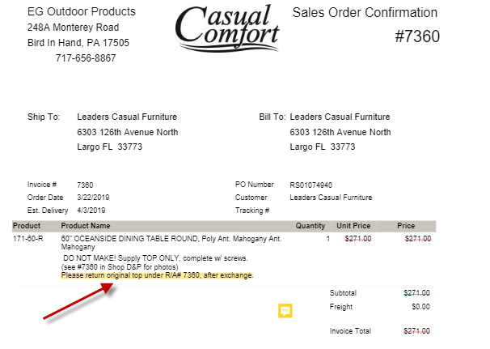

* Once you have the copy of this paperwork, submit an RGA Request in Wrike. To enter in the Wrike request, go to your Wrike work space and select the green plus sign toward the top right of your screen, the same spot you go to in order to enter the Repair and Cushion Shop Requests, except the form you select will be the RGA Request.



* Follow the prompts to enter all of the necessary information the same as you would for a Cushion Shop or Repair Request and submit. Make sure that a copy of the RGA is attached to the request form when prompted. This request will be added to the On Dock Folder as shown below.



* The task is assigned to On Dock and they are the ones who handle the product from here. Solutions will only follow up to make sure the tasks are being completed and that Leader’s is not being charged unnecessarily.
* When the RA is received in or when On Dock is going through all of the active tasks, they are responsible for pulling the product down, labeling it with the paperwork and taking it to the shipping area. On Dock will mark the task complete at that time.
* Once the Shipping team has at least two pallets of product ready to go. The shipping department will arrange for it to be sent back to CCOM.
* Shipping will provide us with the Bill of Lading for each shipment of RGA product that they schedule to CCOM. This paperwork is provided in the form of a packed and includes copies all the RGAs that were sent back on the shipment. Solutions will simply go through the Bill of Lading paperwork and mark Suspended in Wrike, any that are confirmed to have gone back.

For Tropitone

* This process will take place after a claim has been honored and a PO for a new full piece has been submitted to Tropitone.
  + This process does not apply if Tropitone is providing parts only.
* Once they receive and process our PO for new product, they will send the acknowledgement directly to us. Their acknowledgement confirms that they are sending the product we ordered, over to us.
* If we receive the acknowledgement from them, we will need to enter it into NetSuite if it has not been already. The Purchasing team will often receive our acknowledgements as well their own and will enter them on our behalf. It is always best practice to double check. (Process?)
* The acknowledgement will also list instructions about what Tropitone would like for us to do with the defective product once it is returned to us from our customer on an RA.
* Tropitone will either instruct that the product be Field Destroyed or Returned for Credit. An example of the Acknowledgement paperwork and the location of the instructions provided is below.

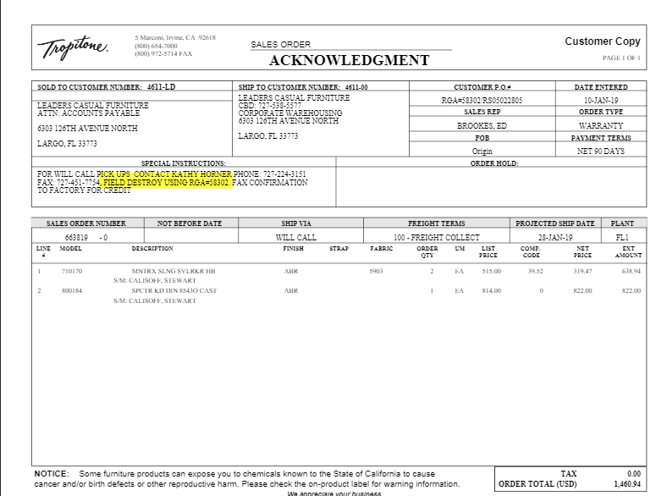

* If for some reason we do not see the acknowledgement paperwork, Tropitone will send us RGA paperwork in another form. Typically this paperwork is sent as the RGA has begun to age in Tropitone’s system, however, both will have the same RGA number and request the same action. An example of the secondary paperwork is below.

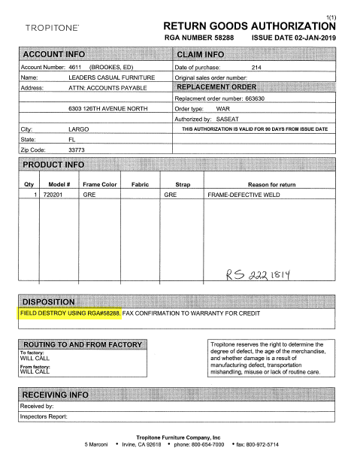

* Once you have the copy of either paperwork, submit an RGA Request in Wrike. To enter in the Wrike request, go to your Wrike work space and select the green plus sign toward the top right of your screen, the same spot you go to in order to enter the Repair and Cushion Shop Requests, except the form you select will be the RGA Request.



* Follow the prompts to enter all of the necessary information the same as you would for a Cushion Shop or Repair Request and submit. Make sure that a copy of the RGA is attached to the request form when prompted. This request will be added to the On Dock Folder as shown below.



* The task is assigned to On Dock and they are the ones who handle the product from here. Solutions will only follow up to make sure they are being completed and that Leader’s is not being charged unnecessarily.
* When the RA is received in or when On Dock is going through all of the open tasks, they are responsible for pulling the product down and arranging for it to be sent back to Tropitone on one of the trucks that we send over to them for the purpose of picking up new merchandise. Once this arrangement has been made, On Dock will mark the task complete in Wrike.
* Solutions will need to work with printed hard copies of all Tropitone RGA paperwork. Once a task is marked completed, Solutions will need to print the corresponding paperwork in either form that is available, write “Completed”, and then sign your name and date.
* After the paperwork is signed, the task can be marked suspended in Wrike.
* The paperwork will need to be given to Bev who will then fax the confirmation over to Tropitone’s accounting department. If we are not handling this paperwork in a timely manner, Tropitone will attempt to charge us for warrantied replacement product.

For Windward

* The process would be followed much the same as for Tropitone with the exception of:
  + We would not give the completed, signed paperwork to Bev to fax.
  + We would only let our contact at Windward know, when it was completed and send them a copy.
* Windward will typically only want product Returned for Credit, never Field Destroyed.
* It is very rare that Windward will request this.

For Jensen

* I have never seen that Jensen wanted us to send product back to them for credit before, only that they would like it Field Destroyed.
* I have also not seen them look to charge us for not verifying that something was Field Destroyed.

For Treasure Garden

* I have never seen Treasure Garden request product to be verified Field Destroyed, but they will occasionally ask for things back.
* When you enter in the Wrike request, notate that the product needs to be pulled to the Shipping department.
* Once the task is marked completed, you will need to reach out to Treasure Garden and ask for them to issue a Call Tag for the merchandise.
* After they confirm they have done so, email the Shipping team to let them know that the product will be being picked up because a Call Tag has been issued. They will complete the process.

For Pride

* As we no longer work with Pride, we do not see many claims for them, however, since they have a lengthy warranty, we will see claims come up periodically.
* Pride does not require that we sign off on product that is being field destroyed.
* If something needs to be Returned for Credit, the Wrike request needs to specify that the product is to be returned using “Old Dominion Freight”. Pride will not cover the shipping charges if this freight carrier is not used.
* As long as the freight carrier is specified in the request, On Dock will know what to do with the product.